Directions to find Limited English Proficiency Demographic Data Set B16001 “Language spoken at home by ability to speak English for the Population Five Years or Older”
- Navigate to the United States Census Bureau Data Website: https://data.census.gov/cedsci/
- Type B16001 in the search bar and select “B16001: Language Spoken at Home by Ability to Speak English”
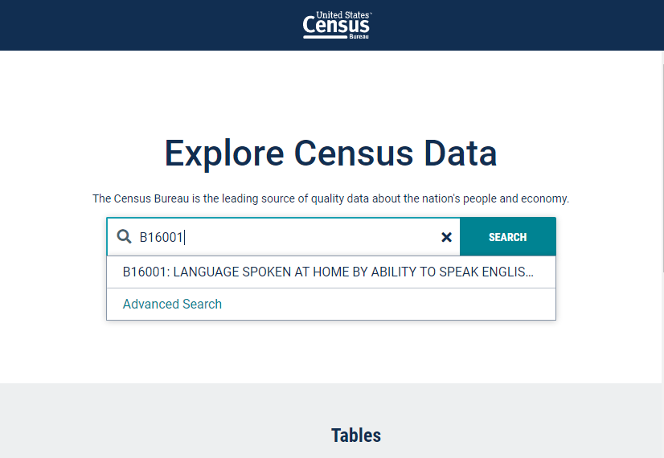
- Navigate to the “Geos” icon on the top rail to filter by your service area, county(s) or city(s). If you service multiple cities but not county-wide, please create individual LEP charts for each city.
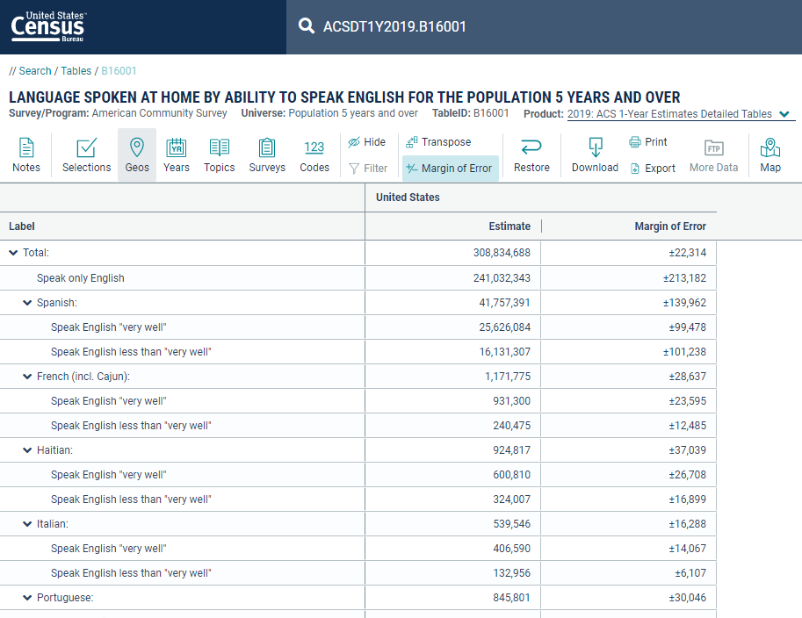

- The following example will be for Phoenix, AZ. From the dropdown menu after clicking “Geos”, select “Place”.
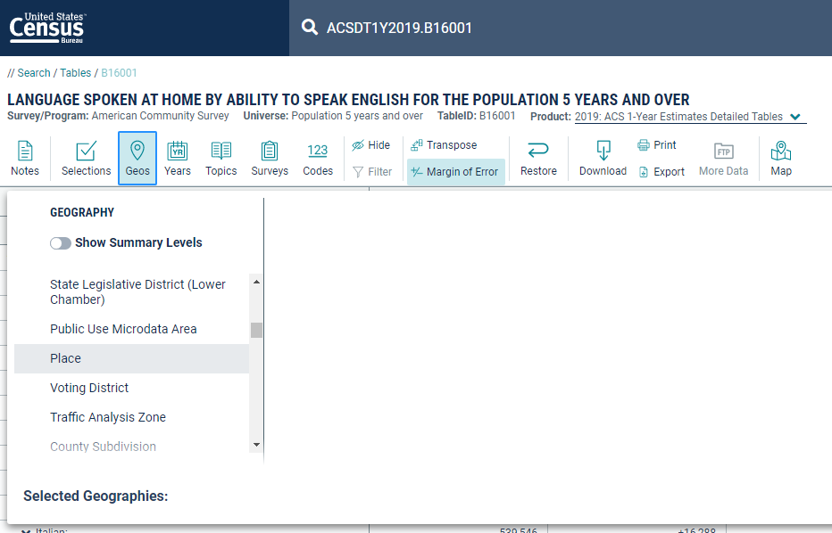
- After selecting “Place”, select the state in the “Within (State)” Menu.
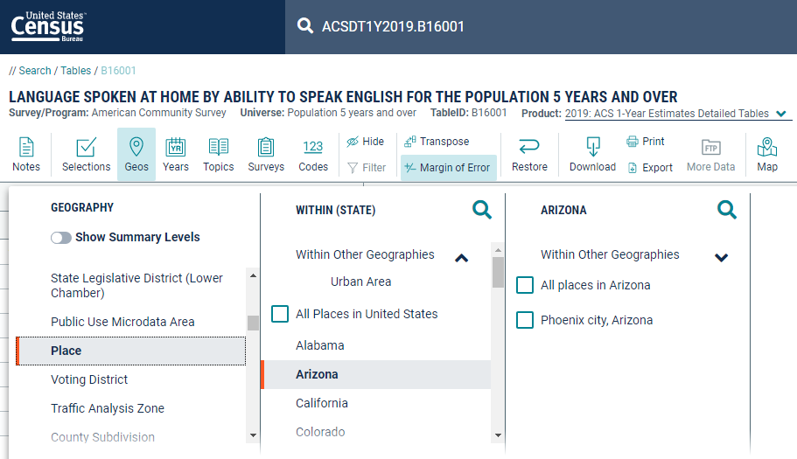
- Select the Magnifying Glass Icon to the right of “Arizona” to filter by specific city or town. Type your location into the Search Bar. Select your desired location in the menu by checking it.
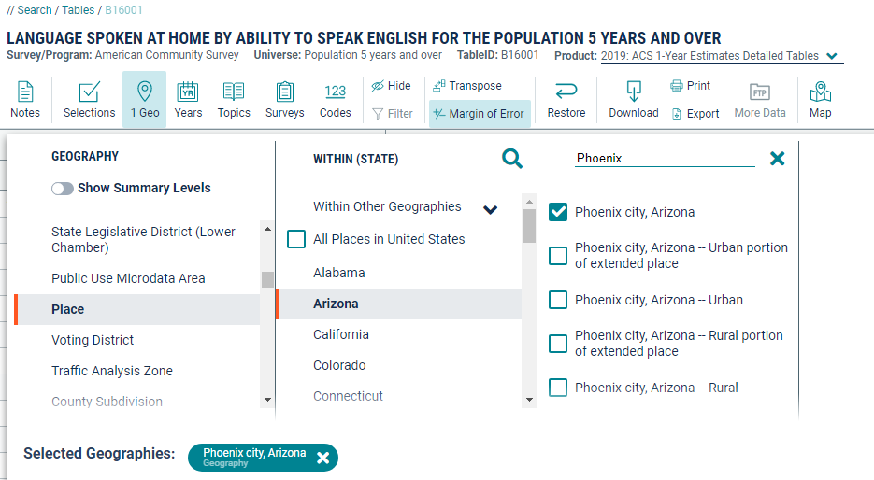
The LEP Demographic Data for your desired location will now display.
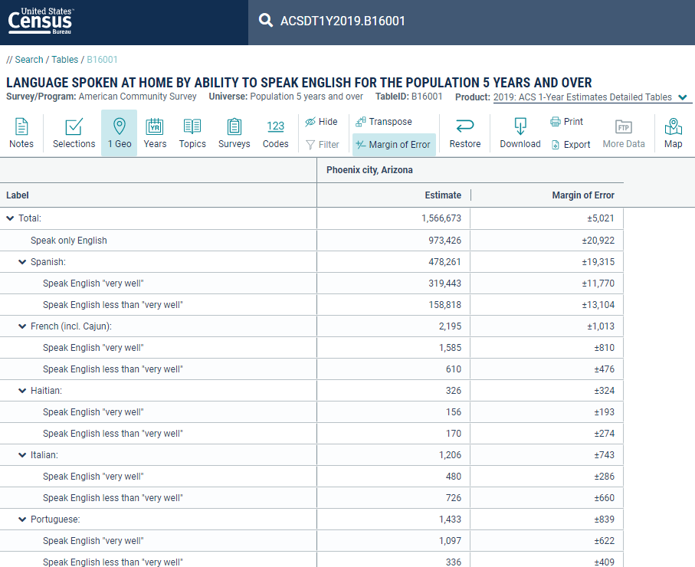
- To export this chart with the correct formatting, you can select & highlight the entire chart, right click, and Export the table as CSV Export and an Excel Export.
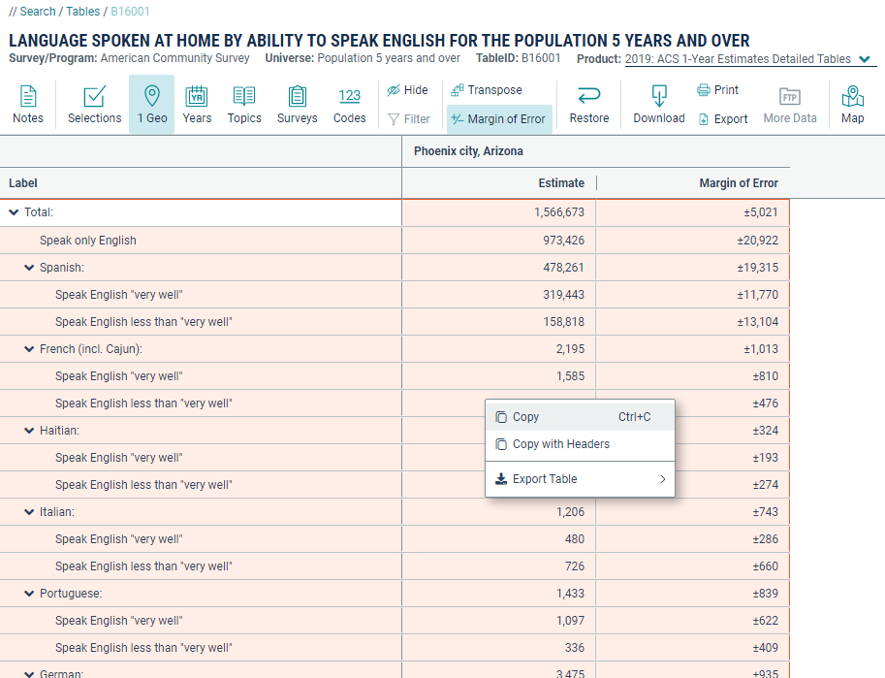
- In Excel or Google Sheets, the exported data will appear as listed below. You will need to adjust the formatting and add appropriate headers.
